**Mathematics for Machine Learning**

Module #1

Vectors in ML are used as features of the dataset(e.g.): - Area of house, No. of rooms, Price, ...etc.

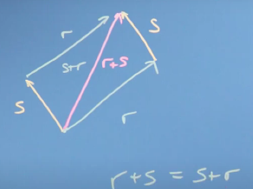Addition

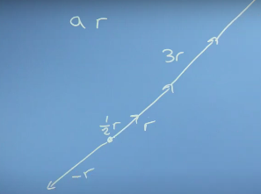

Multiplication

To a scalar

Module #2

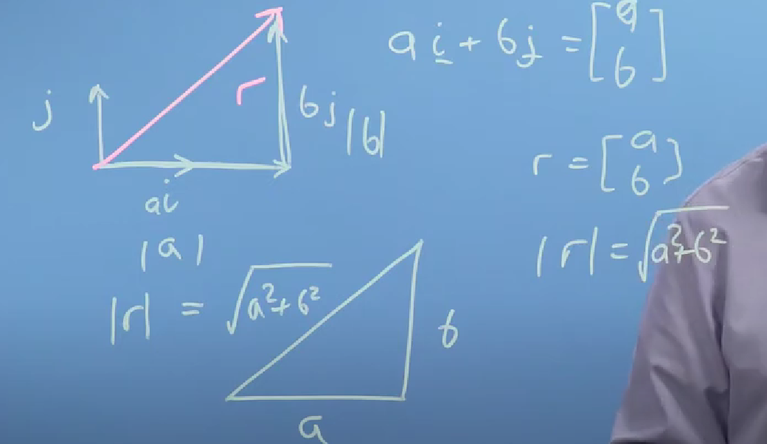Length of vector

r=a i + b j

| r | = sqrt(a2+b2)

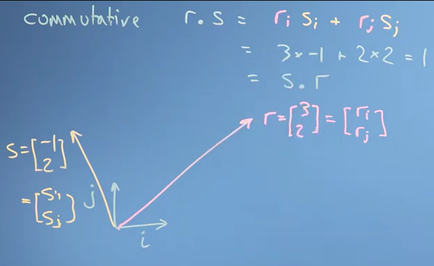Dot product

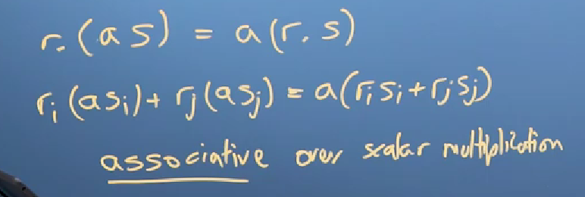

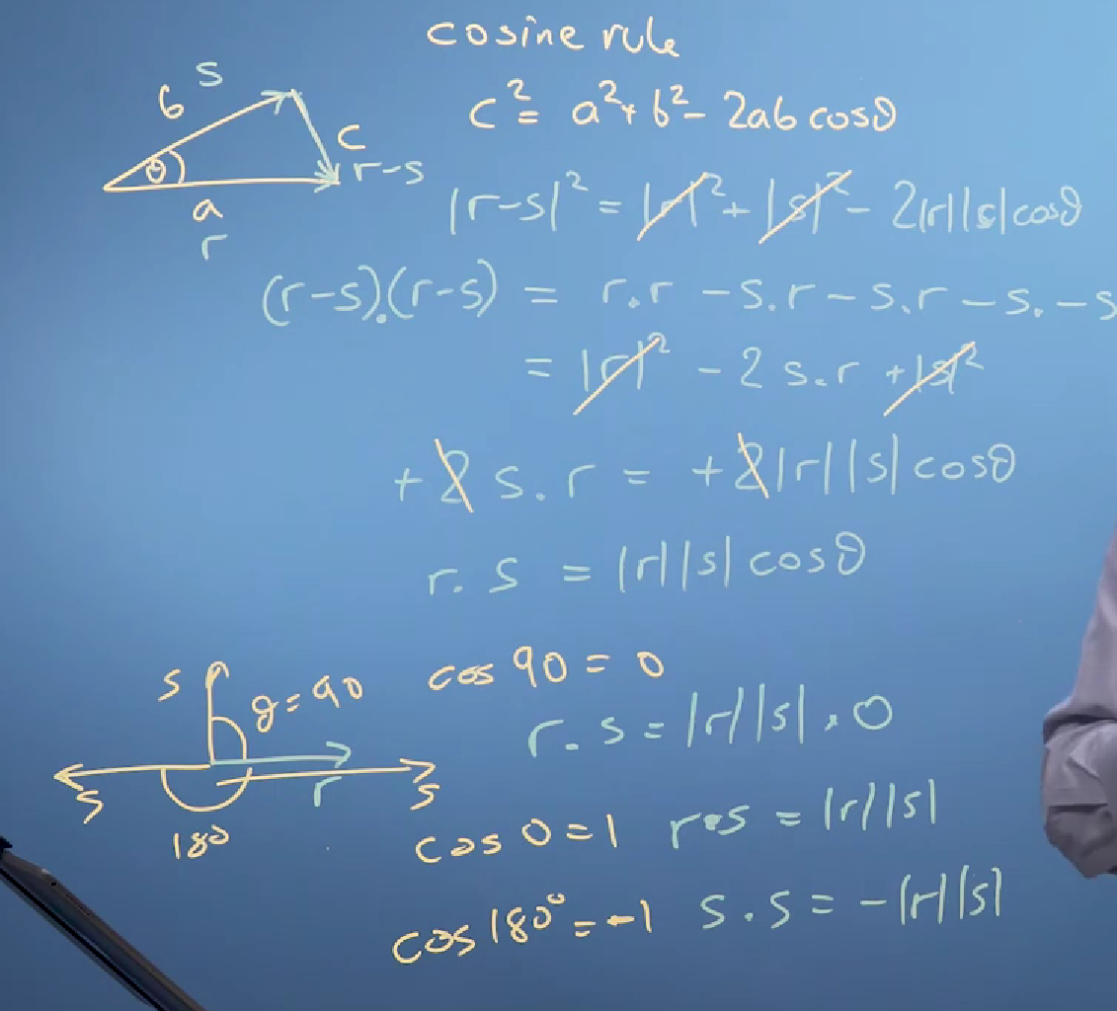



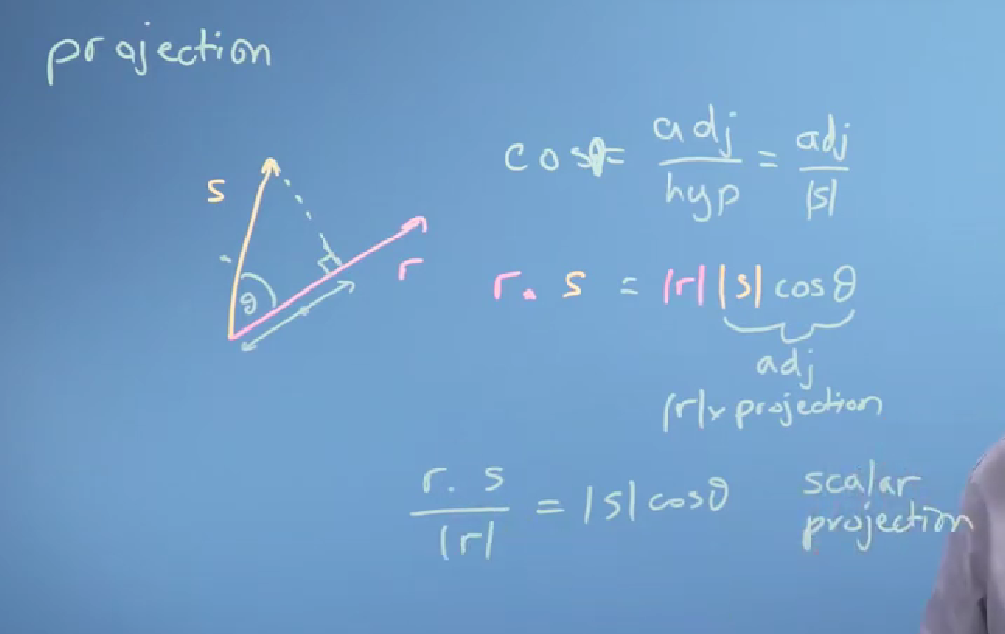



Vector Projection = Scalar Projection * (unit vector of r) = )(r . s(/ [|r| * |r|]( * r

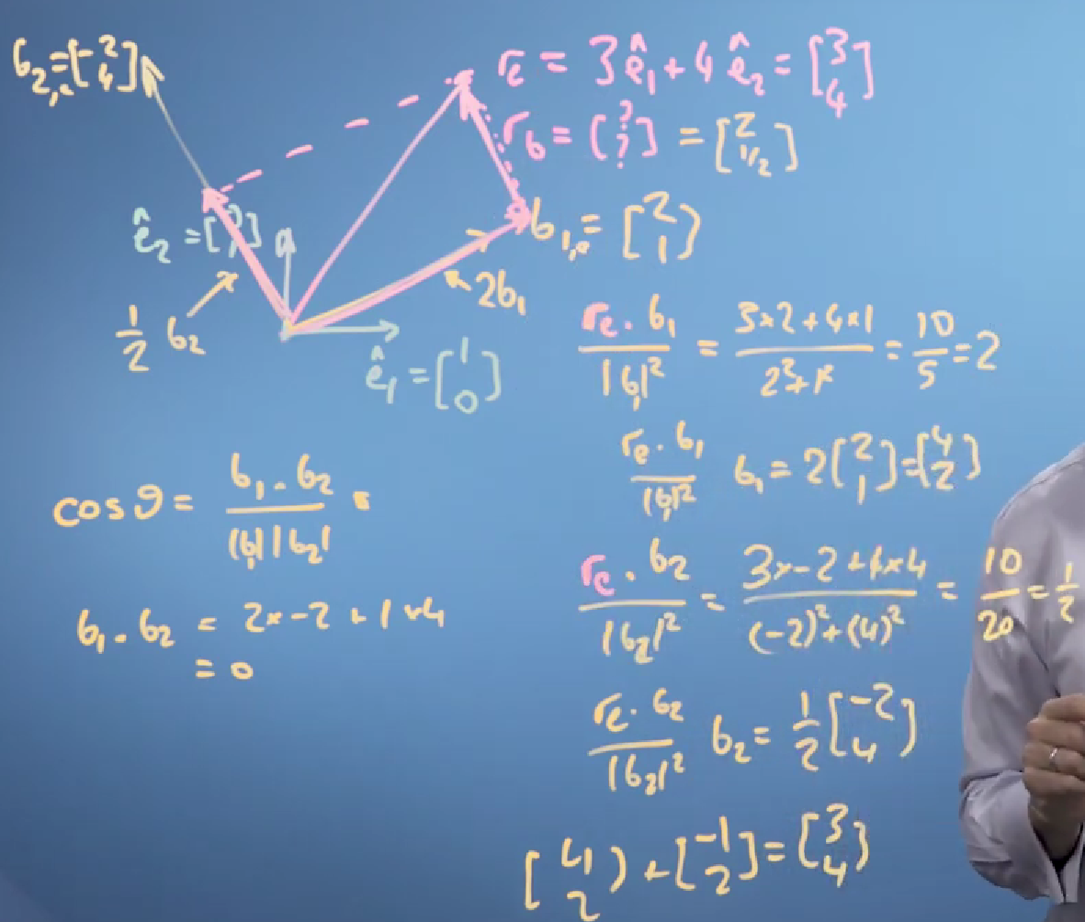Changing basis:

First

Check if new coordinates are

Perpendicular to each other

By using this rule

A dot B = |A| * |B|* Cos(theta)

if cos(theta)=0 => perpendicular

_

Second

Get the Scalar Projection of the vector on the new basis

In example : first scalar proj = (rc dot b1)/|b1|

Second scalar proj =

(rc dot b2)/|b2|

_

Third

Get Vector Projection

First One: b1 * scalar proj1 /|b1|

Second One: b2 * scalar proj2 / |b2|

_

These are the vector in terms of the new basis

Module #3

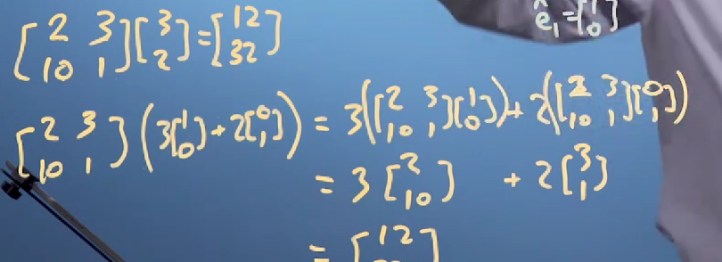

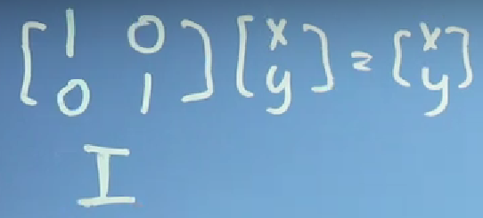

Identity matrix doesn’t change the vectors or matrices that is multiplied by it

Matrix transformation

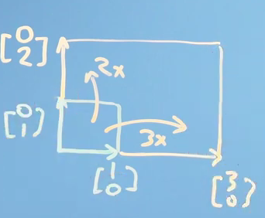Here it multiplies X axis by 3 and y axis by 2

Inversion of matrix is by multiplying it by negative identical matrix.

Mirror1 (45 degree)

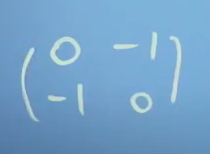

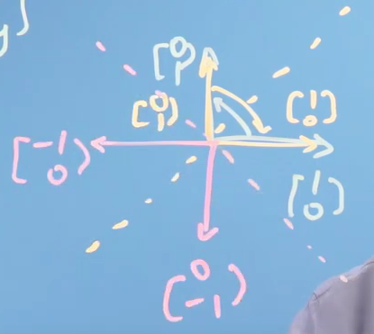Mirror2 (135 degree)

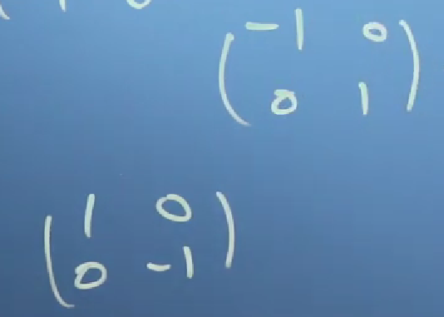

Vertical Mirror (90 degree)

Horizontal Mirror (180 degree)

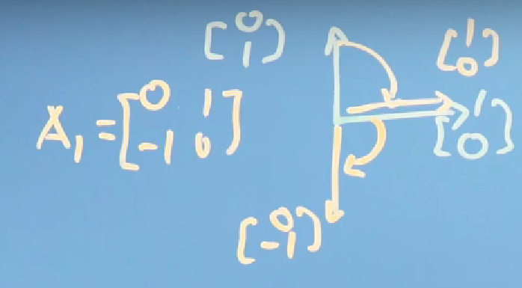_

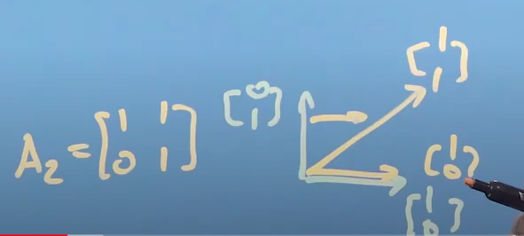

Here we want to shear A1 by A2

So we will shear first vector of A1 by matrix A2 and then shear second vector of A1 by matrix A2

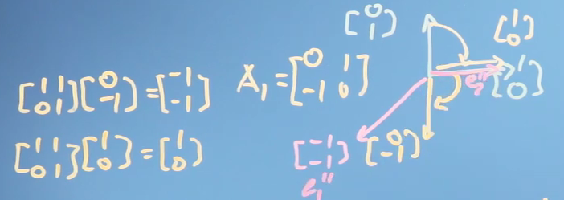

To make this easily you only need to multiply the transformation matrix by the wanted matrix like that:

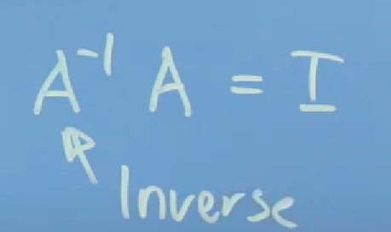

To get the inverse of a matrix we need to make the matrix as (Identity Matrix) which is processed by using Gaussian Elimination. 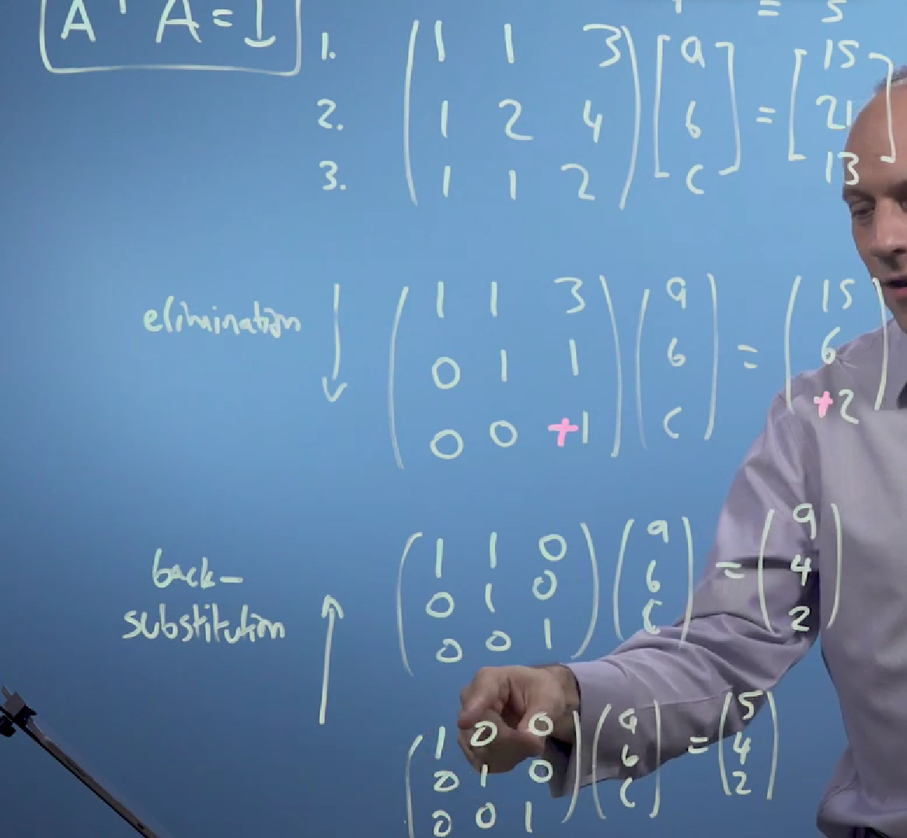

Module #4

To get a specific value from 2 matrices multiplication use this function

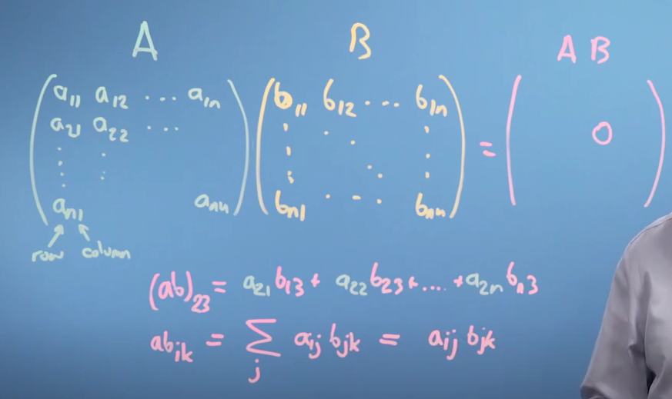

Transforming a vector from a coordinate to another coordinate:

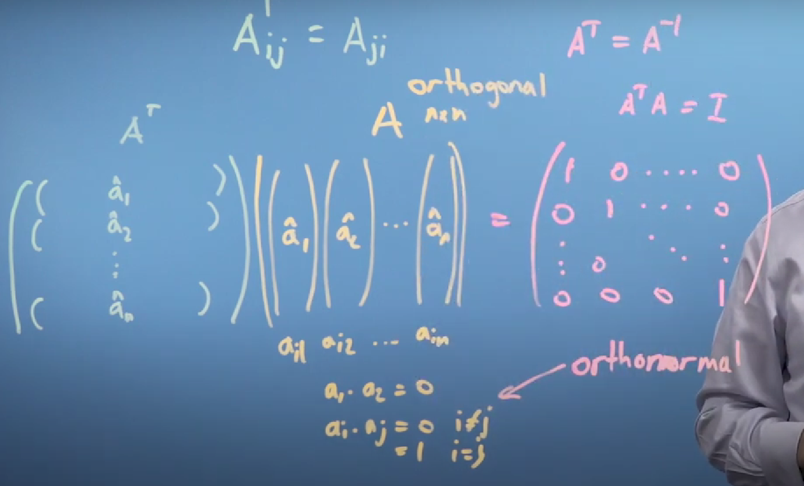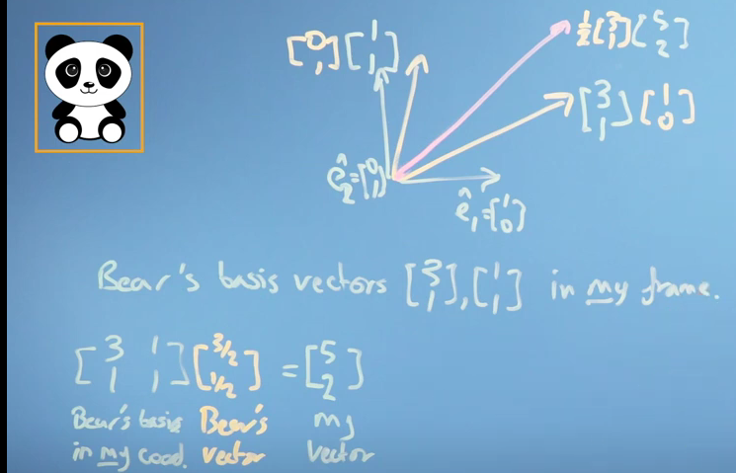

Orthogonal matrix is the matrix which its transpose is the inverse of it.

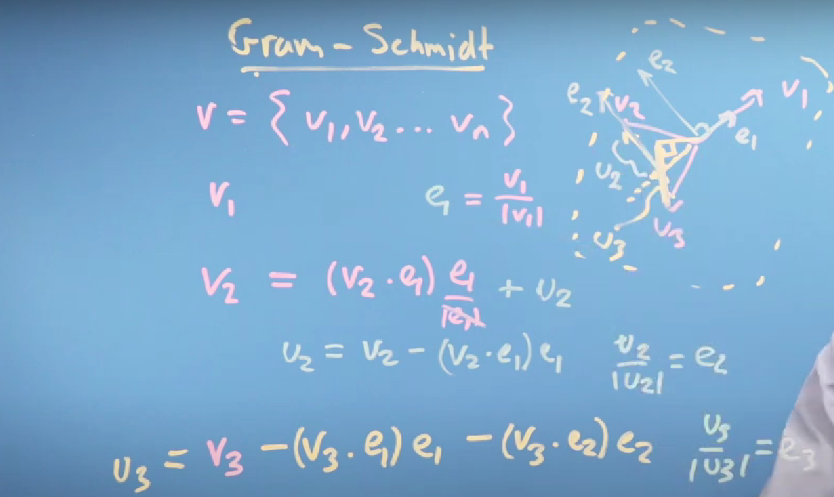Gram Schmidt is a method to make a matrix orthogonal

_

To make it clear first thing we take one of these coordinates and get the unit vector of it lets say V1 so e1=V1/|V1|

Then we get the next vector which is perpendicular to e1 and which is the vector projection of V2 and then we normalize that vector so it is e2.

Then to get the third vector we firstly get the vector which is perpendicular to e1 and which is the vector projection of V3 then we get the vector projection of that vector which perpendicular to e2.

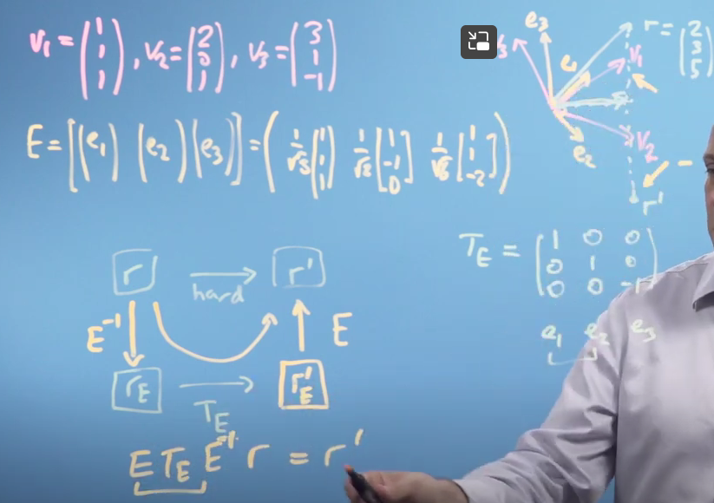

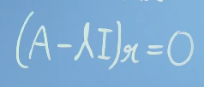Module #5

